Wordbox
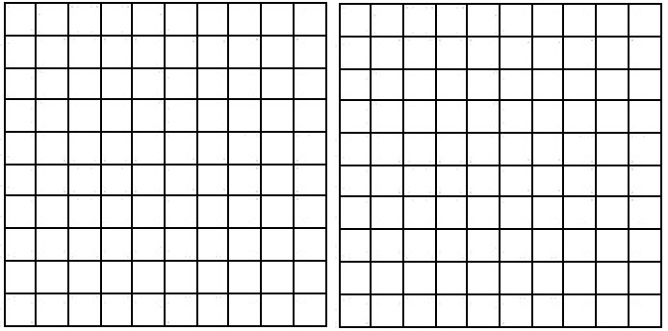

Greek Alphabet

Letter Length
ALPHA (5) ETA (3) NU (2) TAU (3)
BETA (4) THETA (5) XI (2) UPSILON (7)
GAMMA (5) IOTA (4) OMICRON (7) PHI (3)
DELTA (4) KAPPA (5) PI (2) CHI (3)
EPSILON (7) LAMBDA (6) RHO (3) PSI (3)
ZETA (4) MU (2) SIGMA (5) OMEGA (5)

Letter Frequency
A = 17, B = 2, C = 2, D = 2, E =7, F = 0, G = 3, H = 5, I = 10, J = 0, K = 1, L = 5, M = 7
N = 4, O = 7, P = 8, Q = 0, R = 2, S = 4, T = 8, U = 4, V = 0, W = 0, X = 1, Y = 0, Z = 1

Total Number of Words: 24
Total Number of Letters: 100

